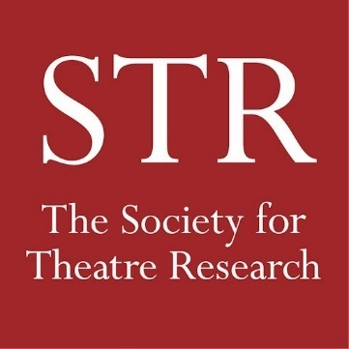
NEW MEMBER ADDITIONAL
BOOK OFFER
Email this form to treasurer@str.org.uk
or post to The Treasurer,
Society for Theatre Research
P.O. Box 78086,
London W4 9LP

Name:Click or tap here to enter name

Address for Delivery: Click or tap here to enter address line 1
Click or tap here to enter address line 2
Click or tap here to enter address line 3
Post Code Click or tap here to enter postcode or zip
Country Click or tap here to enter country

Email or Telephone Click or tap here to enter preferred contact details

Please send me the following 5 books for £25

1. Click or tap here to enter title/author
2. Click or tap here to enter title/author
3. Click or tap here to enter title/author
4. Click or tap here to enter title/author
5. Click or tap here to enter title/author check to choose these ☐ £25

Please send me the 2019/20 publication, Steve Nicholson’s
4 volume The Censorship of British Drama 1900-1968 Free

Please send me The Theatric Tourist by James Winston £20

P&P: payable on books sent to an address outside the UK ☐ £5

TOTAL (please fill this in)

I have paid the above total amount online via PayPal ☐
I have paid by Bank Transfer (details on website) ☐
I have sent a cheque (payable to the Society For Theatre Research)
to the Treasurer at the address given above. ☐

Date: Click or tap here to enter date

