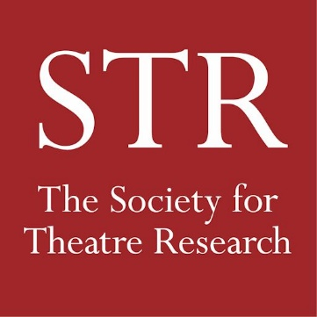
CHRISTMAS BOOK SALE

Email this form to treasurer@str.org.uk
or post to The Treasurer, STR
c/o Department of Theatre and Performance
V&A Blythe House, 23 Blythe Road
London W14 0QX

Name: Click or tap here to enter name

Address for Delivery: Click or tap here to enter address line 1
Click or tap here to enter address line 2
Click or tap here to enter address line 3
Post Code Click or tap here to enter postcode or zip
Country Click or tap here to enter country

Email or Telephone Click or tap here to enter preferred contact details

Please send me the following 3 books for £20

1. Click or tap here to enter title/author
2. Click or tap here to enter title/author
3. Click or tap here to enter title/author check to choose these ☐ £20

or increase to 5 books for £25
4. Click or tap here to enter title/author
5. Click or tap here to enter title/author check to add these ☐ £5

P&P: payable on books sent to an address outside the UK ☐ £5

TOTAL (please fill this in)

I have paid the above total amount online via PayPal ☐
I have paid by Bank Transfer (details on website) ☐
I have sent a cheque (payable to the Society For Theatre Research)
to the Treasurer at the address given above. ☐

Date: Click or tap here to enter date

